Project Design Phase-II

Solution Requirements (Functional & Non-functional)

Date | 03 October 2026
Team ID | SWTID-2026-4310
Project Name | Implement Client Script & UI Policy (Incident)
Program / Module | ServiceNow System Administrator – SkillWallet
Maximum Marks | 4 Marks

Functional Requirements:
Following are the functional requirements of the proposed ServiceNow Incident solution.

FR No. | Functional Requirement (Epic) | Sub Requirement (Story / Sub-Task)
FR-1 | UI Policy Setup | Milestone 1: Create UI Policy on the Incident table.  Milestone 2: Create UI Policy Action for the Urgency field.
FR-2 | Client Script – onChange | Milestone 3: Create an onChange Client Script to respond when the relevant Incident field value changes.
FR-3 | Client Script – onSubmit | Milestone 4: Create an onSubmit Client Script to perform save-time validation before an Incident is submitted.
FR-4 | Client Script – onCellEdit | Milestone 5: Create an onCellEdit Client Script to validate or block invalid Incident updates made directly from a list.
FR-5 | Testing & Enforcement | Milestone 6: Test mandatory-field enforcement, form save validation, reverse-condition behavior, list-edit blocking, and form-based updates.
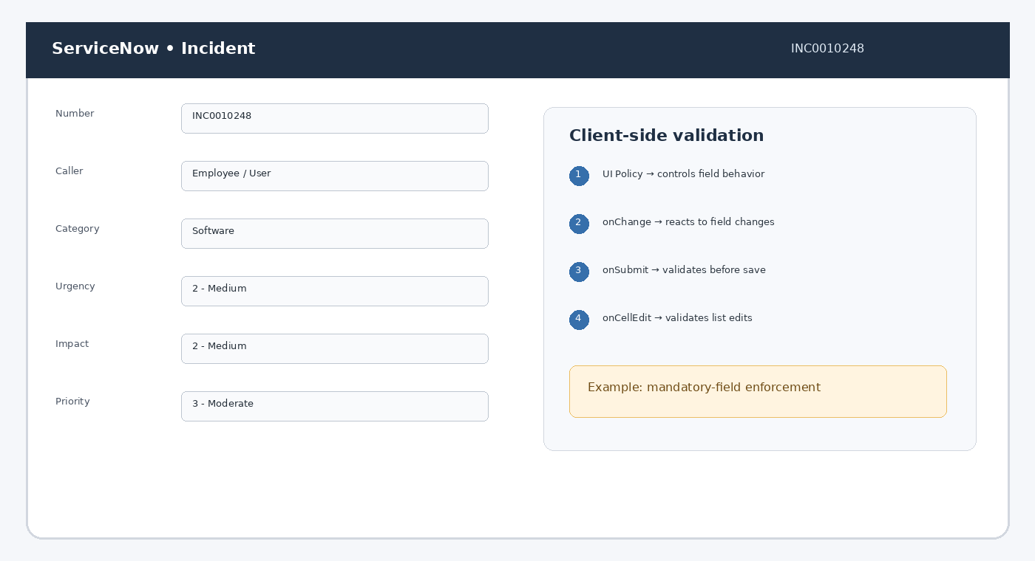

Non-functional Requirements:
Following are the non-functional requirements for the ServiceNow Incident solution.

FR No. | Non-Functional Requirement | Description
NFR-1 | Usability | Incident form behavior should be clear and predictable. UI Policy and client-side validation should guide users without unnecessary steps.
NFR-2 | Security | Client-side controls should complement ServiceNow access controls. Validation must not be treated as a replacement for server-side authorization.
NFR-3 | Reliability | Validation rules should behave consistently for form changes, form submission, reverse conditions, and list-based edits.
NFR-4 | Performance | Client scripts should execute efficiently and avoid unnecessary processing so Incident forms and list editing remain responsive.
NFR-5 | Availability | The solution should work as part of the ServiceNow Incident interface whenever users create, modify, or review Incident records.
NFR-6 | Scalability | The requirements should be structured so additional Incident fields, policies, and validation scenarios can be added without redesigning the entire workflow.
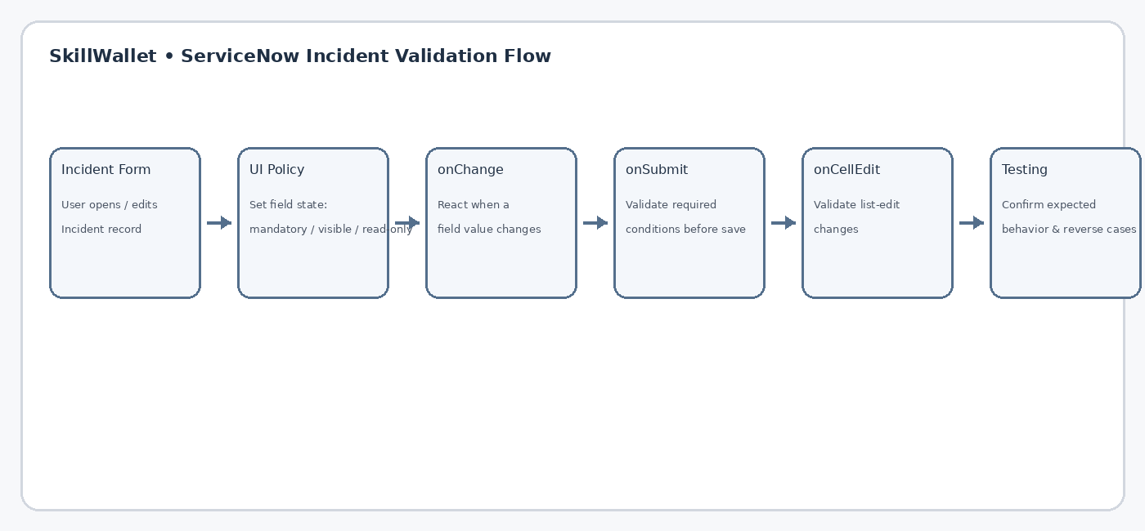

Project Milestone Summary

No. | Milestone | Focus
1 | Create UI Policy | Incident table
2 | Create UI Policy Action | Urgency field
3 | Create onChange Client Script | Field-change behavior
4 | Create onSubmit Client Script | Save validation
5 | Create onCellEdit Client Script | List-edit validation
6 | Testing & Enforcement | Mandatory, reverse, form & list scenarios

